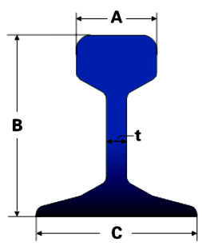
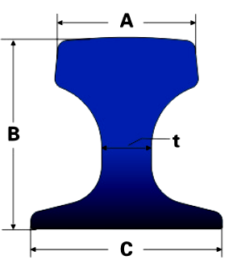
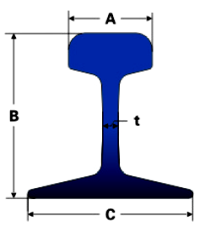
国标 CHINESE STANDARD
SIZE | A | B | C | t | WEIGHT
GB 6KG | 25.4 | 50.8 | 50.8 | 4.76 | 5.98
GB 9KG | 32.1 | 63.5 | 63.5 | 5.9 | 8.94
GB 12KG | 38.1 | 69.85 | 69.85 | 7.54 | 12.2
GB 15KG | 42.86 | 79.37 | 79.37 | 8.33 | 15.2
GB 22KG | 50.8 | 93.66 | 93.66 | 10.72 | 22.3
GB 30KG | 60.33 | 107.95 | 107.95 | 12.3 | 30.1
YB 8KG | 25 | 65 | 54 | 7 | 8.42
YB 18KG | 40 | 90 | 80 | 10 | 18.06
YB 24KG | 51 | 107 | 92 | 10.9 | 24.46
GB 38KG | 68 | 134 | 114 | 13 | 38.733
GB 43KG | 70 | 140 | 114 | 14.5 | 44.653
GB 50KG | 70 | 152 | 132 | 15.5 | 51.514
QU70 | 70 | 120 | 120 | 28 | 52.8
QU80 | 80 | 130 | 130 | 32 | 63.69
QU100 | 100 | 150 | 150 | 38 | 88.96
QU120 | 120 | 170 | 170 | 44 | 118.1
UIC860 STANDARD
SIZE | DIMENSION |  |  |  | WEIGHT  (Kg/m)
SIZE | A(mm) | B(mm) | C(mm) | D(mm) | WEIGHT  (Kg/m)
UIC 54 | 70 | 159 | 140 | 16 | 54.43
UIC60 | 74.3 | 172 | 150 | 16.5 | 60.21
英国标准 BS11:1985 STANDARD
50 'O | 52.39 | 100.01 | 100.01 | 10.32 | 24.833
60 A | 57.15 | 114.3 | 109.54 | 11.11 | 30.618
60 R | 57.15 | 114.3 | 109.54 | 11.11 | 29.822
70 A | 60.32 | 123.82 | 111.12 | 12.3 | 34.807
75 A | 61.91 | 128.59 | 114.3 | 12.7 | 37.455
75 R | 61.91 | 128.59 | 122.24 | 13.1 | 37.041
80 A | 63.5 | 133.35 | 117.47 | 13.1 | 39.761
80 R | 63.5 | 133.35 | 127 | 13.49 | 39.674
90 A | 66.67 | 142.88 | 127 | 13.89 | 45.099
100A | 69.85 | 152.4 | 133.35 | 15.08 | 50.182
113A | 69.85 | 158.75 | 139.7 | 20 | 56.398
德标 DIN536 European Crane Rail
A75 | 85 | 75 | 200 | 45 | 56.2
A100 | 95 | 100 | 200 | 60 | 74.3
A120 | 105 | 120 | 220 | 72 | 100
南非标准 ISCOR STANDARD STEEL RAIL
15KG | 41.28 | 76.2 | 76.2 | 7.54 | 14.905
22KG | 50.01 | 95.25 | 95.25 | 9.92 | 22.542
30KG | 57.15 | 109.54 | 109.54 | 11.5 | 30.25
40KG | 63.5 | 127 | 127 | 14 | 40.31
48KG | 68 | 150 | 127 | 14 | 47.6
57KG | 71.2 | 165 | 140 | 16 | 57.4

日韩标准 JISE1103/1101 STANDARD STEEL RAIL
JIS 15KG | 42.86 | 79.37 | 79.37 | 8.33 | 15.2
JIS 22KG | 50.8 | 93.66 | 93.66 | 10.72 | 22.3
JIS 30 A | 60.33 | 107.95 | 107.95 | 12.3 | 30.1
JIS 37 A | 62.71 | 122.24 | 122.24 | 13.49 | 37.2
JIS 50 N | 65 | 153 | 127 | 15 | 50.4
CR 73 | 100 | 135 | 140 | 32 | 73.3
CR 100 | 120 | 150 | 155 | 39 | 100.2
美国标准 ASTM A1 STANDARD STEEL RAIL
ASCE25 | 38.1 | 69.85 | 69.85 | 7.54 | 12.4
ASCE30 | 42.86 | 79.38 | 79.38 | 8.33 | 14.88
ASCE40 | 47.62 | 88.9 | 88.9 | 9.92 | 19.84
ASCE60 | 60.32 | 107.95 | 107.95 | 12.3 | 29.76
ASCE75 | 62.71 | 122.24 | 122.24 | 13.49 | 37.2
ASCE85 | 65.09 | 131.76 | 131.76 | 14.29 | 42.17
90RA | 65.09 | 142.88 | 130.18 | 14.29 | 44.65
ASCE115 | 69.06 | 168.28 | 139.7 | 15.88 | 56.9
ASCE136 | 74.61 | 185.74 | 152.4 | 17.46 | 67.41
ASCE175 | 109.86 | 152.4 | 152.4 | 38.1 | 86.8

印度标准 ISCR STANDARD STEEL RAIL
ISCR50 | 51.2 | 90 | 90 | 20 | 29.8
ISCR 60 | 61.3 | 105 | 105 | 24 | 40
ISCR 70 | 70 | 120 | 120 | 28 | 52.8
ISCR 80 | 81.7 | 130 | 130 | 32 | 64.2
ISCR100 | 101.9 | 150 | 150 | 38 | 89
ISCR120 | 122 | 170 | 170 | 44 | 118
澳洲标准 AS 1085 STANDARD STEEL RAIL
31KG | 63.5 | 117.5 | 108 | 11.5 | 31.5
41KG | 63.5 | 136.5 | 127 | 13.1 | 40.7
47KG | 70 | 141.3 | 127 | 14.3 | 46.5
50KG | 70 | 154 | 127 | 15 | 50.8
53KG | 70 | 157.1 | 146 | 14.7 | 53
60KG | 70 | 170 | 146 | 16.5 | 61
66KG | 75.4 | 181 | 152 | 16.7 | 65.5
68KG | 73.4 | 186 | 152 | 17.5 | 67.5
73KG | 70 | 157 | 146 | 32 | 73.6
86KG | 102 | 102 | 165 | 84.11 | 85.5
89 KG | 102 | 114 | 178 | 51 | 89.81

